Module:-3
CSS Selectors & Styling
- What is a CSS selector? Provide examples of element, class, and ID selectors ?
A CSS selector is a pattern used in Cascading Style Sheets (CSS) to select and style HTML elements. Selectors determine which elements the CSS rules apply to, based on attributes like element type, class, or ID.
- Element Selector
The element selector selects HTML elements based on the element name.
p {
color: red;
}
This rule applies red text color to all <p> (paragraph) elements
- Class Selector
To select elements with a specific class, write a period (.) character, followed by the class name.
.highlight {
background-color: yellow;
}
This rule applies a yellow background to all elements with class="highlight".
- ID Selector
To select an element with a specific id, write a hash (#) character, followed by the id of the element.
#main-title {
font-size: 24px;
}
This rule sets the font size of the element with id="main-title" to 24 pixels.
2.Explain the concept of CSS specificity. How do conflicts between multiple styles get resolved ?
- CSS stands for Cascading Style Sheets
- CSS describes how HTML elements are to be displayed on screen, paper, or in other media
- CSS saves a lot of work. It can control the layout of multiple web pages all at once
- External stylesheets are stored in CSS files
Specificity Calculation
Specificity is calculated using a four-part value, often represented as (a, b, c, d):
- a: Inline styles (e.g., styles defined directly in the style attribute of an HTML element). This has the highest specificity.
- b: IDs (e.g., selectors that use the # symbol). Each ID in the selector contributes 1 to this value.
- c: Classes, attributes, and pseudo-classes (e.g., selectors that use .class, [attribute], or :hover). Each of these contributes 1 to this value.
- d: Elements and pseudo-elements (e.g., selectors that use element names like div, p, or ::before). Each of these contributes 1 to this value.

Example:
p {
color: red;
}
.aaa {
color: aqua;
}
#bbb {
color: blue;
}
Always output is blue.

3.What is the difference between internal, external, and inline CSS? Discuss the advantages and disadvantages of each approach.

1. Inline CSS
Definition: Inline CSS involves applying styles directly to individual HTML elements using the style attribute.
Advantages:
- Specificity: Allows for quick and specific styling of individual elements.
- No External Files Needed: Useful for small projects or testing, as it doesn't require separate CSS files.
Disadvantages:
- Maintainability Issues: As projects grow, managing inline styles becomes cumbersome. Changes need to be made to each element individually.
- Code Redundancy: Leads to repetitive code when multiple elements share the same styles.
- Separation of Concerns: Mixes content with presentation, which is against best practices.

2. Internal CSS
- Definition: Internal CSS involves placing CSS rules within a <style> tag inside the <head> section of an HTML document.
Advantages:
- Page-Specific Styling: Useful for applying unique styles to a single page without affecting others.
- No External Dependencies: Styles are loaded with the HTML, reducing HTTP requests.
Disadvantages:
- Redundancy Across Pages: If multiple pages require the same styles, code duplication occurs.
- Maintenance Challenges: Updating styles across multiple pages becomes time-consuming.
- Increased HTML Size: Embedding styles increases the size of the HTML file.

3. External CSS
- Definition: External CSS involves linking to a separate .css file using the <link> tag in the HTML document's <head> section.
Advantages:
- Reusability: A single CSS file can style multiple pages, ensuring consistency.
- Maintainability: Updating styles in one place reflects across all linked pages.
- Cleaner HTML: Keeps HTML files uncluttered and focused on content.
- Caching Benefits: Browsers can cache the CSS file, improving load times on subsequent visits.
Disadvantages:
- Additional HTTP Request: Requires an extra request to fetch the CSS file, which can affect load times, especially on slow connections.
- Dependency on External File: If the CSS file fails to load, the page may appear un styled.
CSS Box Model
- Explain the CSS box model and its components (content, padding, border, margin). How does each affect the size of an element?
The CSS Box Model is a fundamental concept in web layout. It treats every HTML element as a rectangular “box” composed of four layers, from inside out
Content:
Definition: This is the innermost part of the box model, where text, images, or other media are displayed.
Size: The size of the content area is defined by the width and height properties in CSS. The content area is the starting point for calculating the total size of the element.
Padding:
Definition: Padding is the space between the content and the border of the box. It creates an inner buffer around the content.
Size: Padding adds to the overall size of the element. If you set padding using the padding property, it increases the dimensions of the box. For example, if the content area is 100px wide and you add 10px of padding on all sides, the total width becomes 120px (100px + 10px left + 10px right).

Border:
Definition: The border surrounds the padding (if any) and the content. It can be styled with different widths, colors, and styles (solid, dashed, etc.).
Size: The border also contributes to the total size of the element. If you have a 2px border on all sides, it adds 4px to the total width (2px left + 2px right) and 4px to the total height (2px top + 2px bottom).
Margin:
Definition: Margin is the outermost space that separates the element from other elements on the page. It creates space outside the border.
Size: Margins do not affect the size of the element itself but do affect the spacing between elements. If you set a margin of 10px, it will create a 10px space outside the border, but it does not increase the element's width or height.

BOX MODEL:
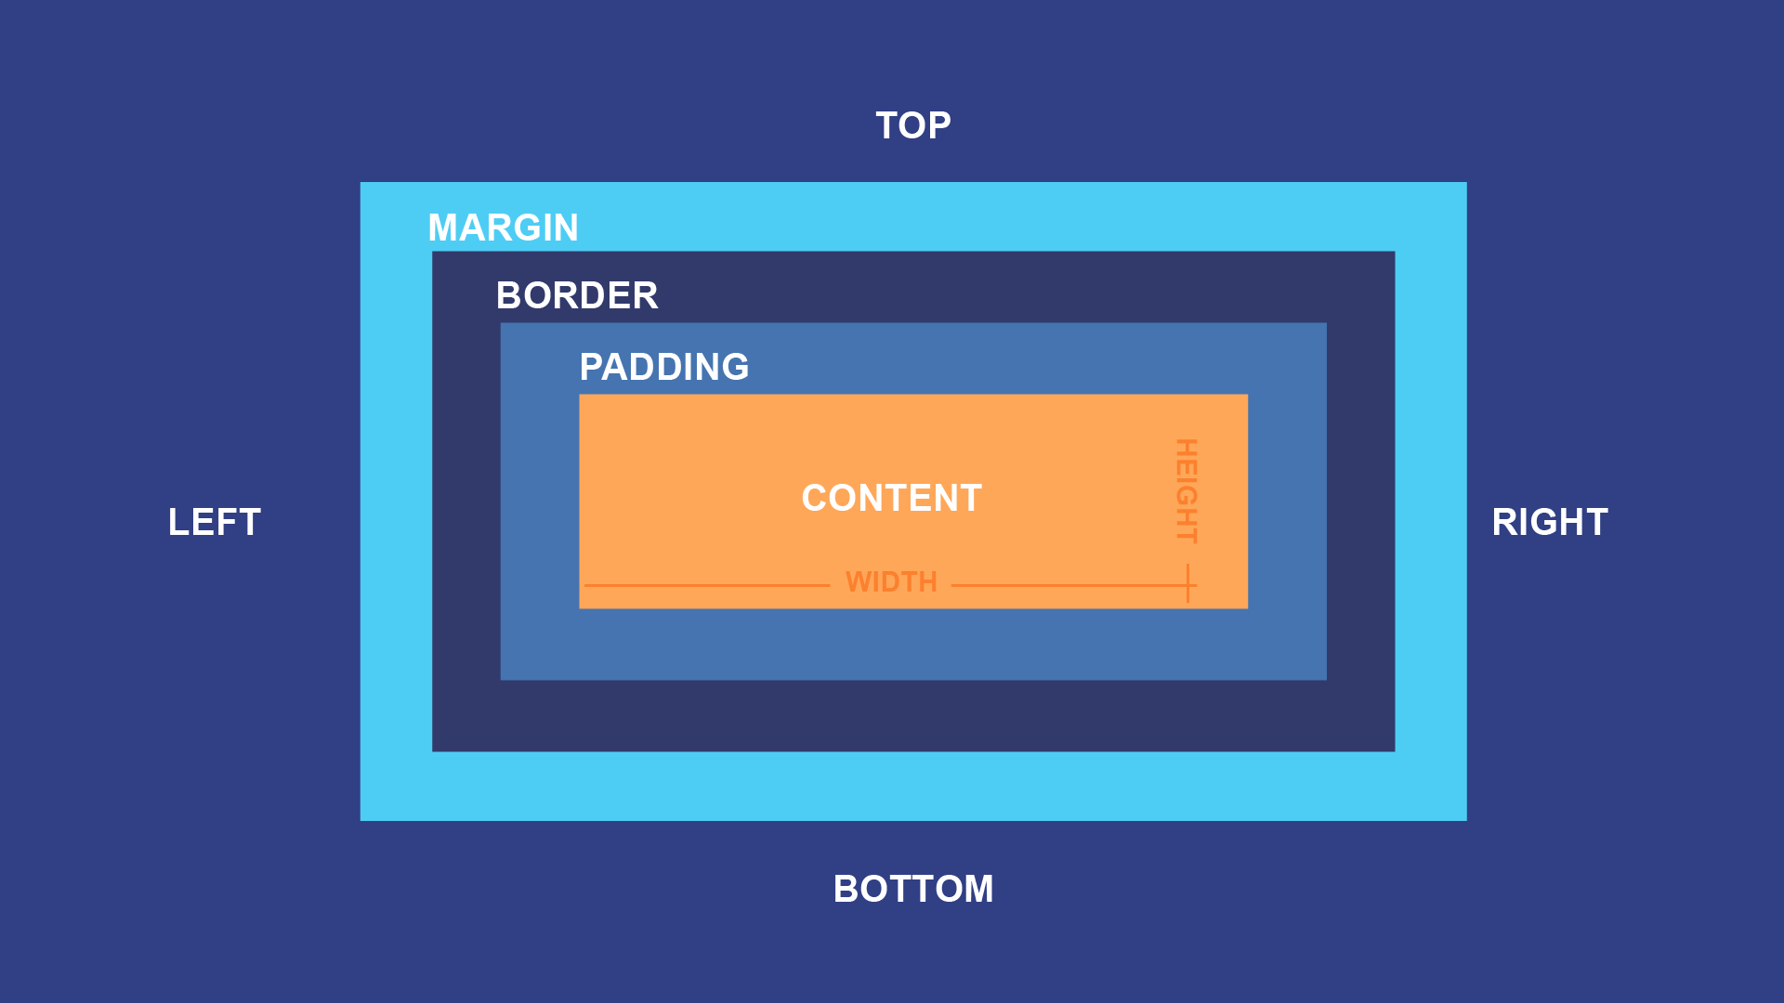

2.What is the difference between border-box and content-box box-sizing in CSS? Which is the default?
In CSS, the box-sizing property defines how the width and height of an element are calculated, including padding and borders. There are two main values for this property: content-box and border-box.
- content-box:
  - This is the default value for the box-sizing property.
  - When using content-box, the width and height of an element are calculated only for the content area. Padding and borders are added outside of this width and height.
  - For example, if you set an element's width to 200px and add 20px of padding and a 5px border, the total width will be 200px (content) + 20px (padding) + 5px (border) = 225px.
- border-box:
  - When using border-box, the width and height of an element include the content, padding, and border.
  - This means that if you set an element's width to 200px, that total width will include the content, padding, and border. If you add 20px of padding and a 5px border, the content area will shrink to accommodate these values, ensuring the total width remains 200px.
- Default: content-box
- Behavior:
  - content-box: Width/Height = Content only
  - border-box: Width/Height = Content + Padding + Border
Using border-box can often simplify layout calculations, as it allows you to set a width or height without worrying about additional padding or borders affecting the total size of the element.
CSS Flexbox
- What is CSS Flexbox, and how is it useful for layout design? Explain the terms flex-container and flex-item.
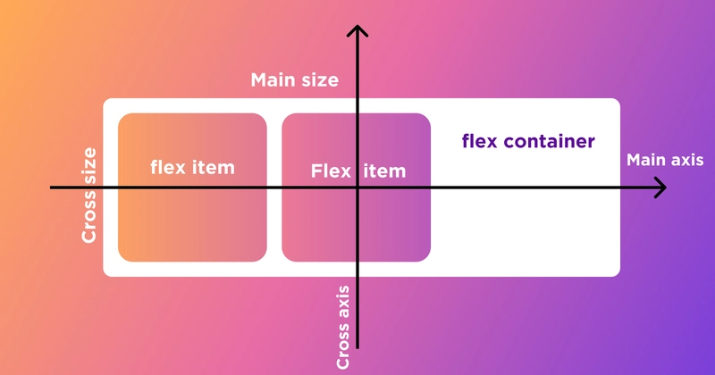
CSS Flexbox, or the Flexible Box Layout, is a layout model that provides a more efficient way to design complex layouts and align items within a container. It allows for responsive design by enabling items to grow, shrink, and be distributed within a container, regardless of their size.
Key Features of Flexbox:
- Direction Control: Flexbox allows you to define the direction of the layout (row or column) using the flex-direction property.
- Alignment: You can easily align items along the main axis (horizontal or vertical) and the cross axis using properties like justify-content and align-items.
- Flexibility: Items can grow to fill available space or shrink to fit into smaller spaces using the flex-grow, flex-shrink, and flex-basis properties.
- Order Control: You can change the visual order of items without altering the HTML structure using the order property.
Flex Container
- Defined by applying display: flex or inline-flex to a parent element.
- It sets up a flex formatting context: establishes the main axis (row/column direction) and the cross axis (perpendicular direction).
- Key container properties:
  - flex-direction: row, row-reverse, column, column-reverse – controls main-axis orientation
  - flex-wrap: nowrap (default), wrap, wrap-reverse – allows items to wrap to new lines
  - justify-content: aligns items along the main axis (start, center, end, space-between/around/evenly)
  - align-items: aligns items along the cross axis (start, center, end, stretch, baseline).
  - align-content: aligns multiple flex lines along cross axis when wrapping is enabled
Flex Item
- Any direct child of a flex container.
- They are laid out according to flex container rules and have their own flexible properties
- Key item properties:
  - order: controls visual order independently of DOM order
  - flex-grow: proportionally grows items to fill available space
  - flex-shrink: defines how items shrink when there's insufficient space
  - flex-basis: sets initial size before flexing
  - flex: shorthand for grow, shrink, and basis.
  - align-self: overrides align-items for individual items on the cross axis
2.Describe the properties justify-content, align-items, and flex- direction used in Flexbox.
1. flex-direction
  - Description: This property defines the direction in which the flex items are placed in the flex container.
  - Values:
    - row: (default) Items are placed in a row from left to right.
    - row-reverse: Items are placed in a row from right to left.
    - column: Items are placed in a column from top to bottom.
    - column-reverse: Items are placed in a column from bottom to top.
2.justify-content
- Description: This property aligns the flex items along the main axis (the direction defined by flex-direction). It controls the distribution of space between and around the items.
- Values:
  - flex-start: Items are packed toward the start of the flex container (default).
  - flex-end: Items are packed toward the end of the flex container.
  - center: Items are centered along the main axis.
  - space-between: Items are evenly distributed in the container, with the first item at the start and the last item at the end.
  - space-around: Items are evenly distributed with equal space around them.
  - space-evenly: Items are evenly distributed with equal space between them and at the edges.
3.align-items
- Description: This property aligns the flex items along the cross axis (perpendicular to the main axis). It controls how items are aligned within the flex container.
- Values:
  - stretch: (default) Items are stretched to fill the container along the cross axis.
  - flex-start: Items are aligned at the start of the cross axis.
  - flex-end: Items are aligned at the end of the cross axis.
  - center: Items are centered along the cross axis.
  - baseline: Items are aligned along their baseline.
.container {
display: flex; /* make it a flex container */
flex-direction: row; /* main axis is horizontal by default */
justify-content: space-between; /* distribute space evenly horizontally */
align-items: center; /* vertically center items */
}

CSS Grid
1.Explain CSS Grid and how it differs from Flexbox. When would you use Grid over Flexbox?

CSS Grid:
Key Features:
- Two-Dimensional Control: Allows precise placement of items in both horizontal and vertical axes.
- Grid Areas: Enables naming specific areas of the layout for easier management.
- Fractional Units (fr): Distributes space proportionally among grid tracks.
- Layering: Supports overlapping elements within the grid.
Use Cases:
- Complex page layouts with multiple sections.
- Designs requiring alignment in both dimensions.
- Responsive designs that adjust both rows and columns.
Flexbox:
Key Features:
- One-Dimensional Control: Manages layout in a single direction.
- Content-Based Sizing: Items can grow or shrink to fit the container.
- Alignment: Easily centers items and distributes space.
- Order Management: Allows changing the visual order of elements.
Use Cases:
- Navigation bars.
- Aligning items in a row or column.
- Simple responsive layouts.
Differences Between CSS Grid and Flexbox
- Dimension: Grid is two-dimensional (rows and columns), while Flexbox is one-dimensional (either rows or columns).
- Use Cases: Grid is better for complex layouts that require precise control over both dimensions, while Flexbox is ideal for simpler layouts or when you need to align items in a single direction.
- Item Placement: In Grid, you can place items in specific grid cells, whereas in Flexbox, items are placed in the order they appear in the HTML.

2.Describe the grid-template-columns, grid-template-rows, and grid-gap properties. Provide examples of how to use them.

1. grid-template-columns
The grid-template-columns property defines the number and size of the columns in a grid layout. You can specify fixed sizes, percentages, or use the fr unit, which represents a fraction of the available space.
EXAMPLE:
.container {
display: grid;
grid-template-columns: 100px 200px 1fr;
}
In this example, the grid will have three columns: the first column will be 100 pixels wide, the second will be 200 pixels wide, and the third will take up the remaining space.
2. grid-template-rows
The grid-template-rows property defines the number and size of the rows in a grid layout. Similar to grid-template-columns, you can use fixed sizes, percentages, or the fr unit.
EXAMPLE:
.container {
display: grid;
grid-template-rows: 50px auto 2fr;
}
In this example, the grid will have three rows: the first row will be 50 pixels tall, the second row will automatically adjust its height based on content, and the third row will take up twice the remaining space.
3. grid-gap:
The grid-gap property (also known as gap) defines the spacing between rows and columns in a grid layout. You can specify a single value for uniform spacing or two values for different row and column gaps.
EXAMPLE:
.container {
display: grid;
grid-template-columns: repeat(3, 1fr);
grid-template-rows: repeat(2, 100px);
grid-gap: 20px;
}
In this example, the grid will have three equal columns and two rows, with a 20-pixel gap between both rows and columns.
Property | What It Does | Example Default
grid-template-columns | Defines column sizes/tracks | 100px 200px 1fr;
grid-template-rows | Defines row heights | 50px auto 2fr;
gap (or row-gap, column-gap) | Sets gutters between rows/columns | 20px;

Responsive Web Design with Media Queries
1.What are media queries in CSS, and why are they important for responsive design?

Media queries in CSS are a fundamental feature that allows developers to apply different styles to a web page based on the characteristics of the device or viewport displaying the content. They enable responsive design by allowing the layout and appearance of a website to adapt to various screen sizes, resolutions, and orientations.
What are Media Queries?
A media query consists of a media type (such as screen, print, etc.) and one or more expressions that check for specific conditions, such as viewport width, height, resolution, and orientation. When the conditions of a media query are met, the styles defined within that media query are applied.
BASIC SYNTAX:
@media media-type and (condition) {
/* CSS rules here */
}
EXAMPLE:
@media screen and (max-width: 600px) {
body {
background-color: lightblue;
}
}
In this example, if the viewport width is 600 pixels or less, the background color of the body will change to light blue.
Importance of Media Queries for Responsive Design
- Adaptability: Media queries allow web pages to adapt to different screen sizes and resolutions, ensuring that content is accessible and visually appealing on a wide range of devices, from mobile phones to large desktop monitors.
- Improved User Experience: By tailoring the layout and design to fit the user's device, media queries enhance the overall user experience. This includes adjusting font sizes, navigation menus, images, and other elements to ensure they are easy to read and interact with.
- Performance Optimization: Media queries can help optimize performance by loading only the necessary styles for a specific device. This can reduce the amount of CSS that needs to be processed, leading to faster load times.
- Separation of Concerns: Media queries promote a clean separation of styles for different devices, making it easier to maintain and update the CSS code. Developers can organize styles based on device characteristics rather than creating separate stylesheets for each device.
- Future-Proofing: As new devices with varying screen sizes and resolutions continue to emerge, media queries provide a flexible way to ensure that websites remain functional and visually appealing across all platforms.

2.Write a basic media query that adjusts the font size of a webpage for screens smaller than 600px

@media (max-width: 600px) {
body {
font-size: 14px;
}
}
Typography and Web Fonts
1.Explain the difference between web-safe fonts and custom web fonts. Why might you use a web-safe font over a custom font?
Web-Safe Fonts
Definition: Web-safe fonts are a set of fonts that are universally available across all major operating systems and browsers. These fonts are pre-installed on most devices, ensuring that they will render correctly regardless of the user's system.
Common Examples: Arial, Times New Roman, Courier New, Georgia, Verdana, and Trebuchet MS.
Advantages:
- Consistency: Since these fonts are widely available, they ensure a consistent appearance across different devices and browsers.
- Performance: Web-safe fonts do not require additional loading time, as they are already installed on the user's device.
- Simplicity: Using web-safe fonts can simplify the design process, as you don't need to worry about font licensing or embedding.
Custom Web Fonts
Definition: Custom web fonts are fonts that are not typically installed on user devices and are loaded from a web server using services like Google Fonts, Adobe Fonts, or self-hosted font files.
Advantages:
- Design Flexibility: Custom fonts allow for unique typography that can enhance branding and visual appeal.
- Variety: There is a vast selection of custom fonts available, enabling designers to choose styles that fit their specific needs.
- Brand Identity: Custom fonts can help establish a distinct brand identity, making a website stand out.
Reasons to Use Web-Safe Fonts Over Custom Fonts
- Performance: Web-safe fonts load faster since they do not require additional HTTP requests to fetch font files, which can improve page load times.
- Compatibility: Web-safe fonts are guaranteed to display correctly on all devices and browsers, reducing the risk of rendering issues.
- Simplicity: For projects that require a straightforward design or where typography is not a primary focus, web-safe fonts can simplify the development process.
- Accessibility: Some users may have issues with custom fonts, such as rendering problems or accessibility concerns. Web-safe fonts are more likely to be readable across different platforms.
2.What is the font-family property in CSS? How do you apply a custom Google Font to a web page ?
- "Font Name": The name of the custom font (enclosed in quotes if it contains spaces).
- fallback-font: A font that will be used if the preferred font is not available.
- generic-family: A general font category (e.g., serif, sans-serif, monospace, etc.) that serves as a last resort.
EXAMPLE:
p {
font-family: "Open Sans", Arial, sans-serif;
}
Applying a Custom Google Font to a Web Page
- Choose a Google Font:
  - Go to the Google Fonts website.
  - Browse and select the font you want to use.
- Embed the Font:
  - After selecting a font, Google Fonts will provide you with a <link> tag to include in the <head> section of your HTML document. For example:
<head>
<link href="https://fonts.googleapis.com/css2?family=Roboto:wght@400;700&display=swap" rel="stylesheet">
</head>
3.Use the Font in CSS:
- In your CSS file or within a <style> tag in your HTML, apply the font-family property to the desired elements. For example:
#air {
color: blue;
}

